Name _____________________________________________________________________________
-est word family
Directions: Choose a chest. Color it appropriately. Write the word for the picture that is on the chest. All words will end with -est.

- 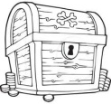 __________________________ 4. ___________________________

- __________________________ 5. ___________________________

- __________________________ 6. ___________________________

Choose 1 –est word and write a sentence.
__________________________________________________________________________________
__________________________________________________________________________________

